December 2019
Orange Team
Schedule
Sunday | Monday | Tuesday | Wednesday | Thursday | 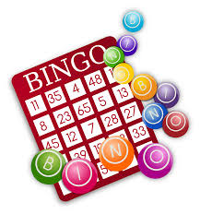  Friday | Saturday
1 | 2  Life Skills  Elective  Isiah’s Birthday | 3  N2Y  Elective | 4  Field Trip:  Christmas Group Lunch Outing ($15) | 5  Life Skills  Elective | 6 | 7
3
8 | 9 | 10 | 11 | 12 | 13 | 14
Bowling at Red Bird Lanes in Duncanville  3-5pm | Cooking  Elective  Super Hooper at OCS 6:30-8:30 | N2Y  Elective | Cooking  Elective | Field Trip:  Walmart Shopping for Secret Santa  ($7) | Games  Christmas Movie  Christmas Dance  @6:30Pm
15 | 16 | 17 | 18 | 19 | 20 | 21
 | The Polar Express  Book/Movie  Cedric’s Birthday | SEC Service Day  Christmas Caroling  @ The Village at Dallas | Field Trip:  North Park Mall  ($7) | Make/Decorate Christmas Cookies  Charlie Brown Christmas | Christmas Movies  Birthday Friday  ($4)
22 | 23 | 24 | 25 | 26 | 27 | 28
 | CLOSED | CLOSED |  | CLOSED | CLOSED | CLOSED
29 | 30 | 31 | The Soaring Eagle Center will be closed on Wednesday, January 1st. Normal hours will resume on Thursday, January 2nd.
 | CLOSED | CLOSED  Luthando’s Birthday

