November 2019
Purple Team
Schedule
Sunday | Monday | Tuesday | Wednesday | Thursday | 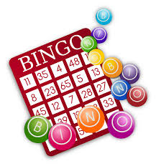  Friday | Saturday
Soaring Eagle Center Basketball Meeting-November 5th, 7-9PM |  |  |  |  | 1 | 2
3
3 | 4 | 5 | 6 | 7 | 8 | 9
 | Cooking  Elective | Thrift Store Shopping  Elective  A.J.’s Birthday | N2Y  Elective  Brittney’s Birthday | Life Skills  Elective | Games  Art
10 | 11 | 12 | 13 | 14 | 15 | 16
Bowling at Red Bird Lanes in Duncanville  3-5pm  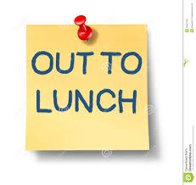 | Cooking  Elective  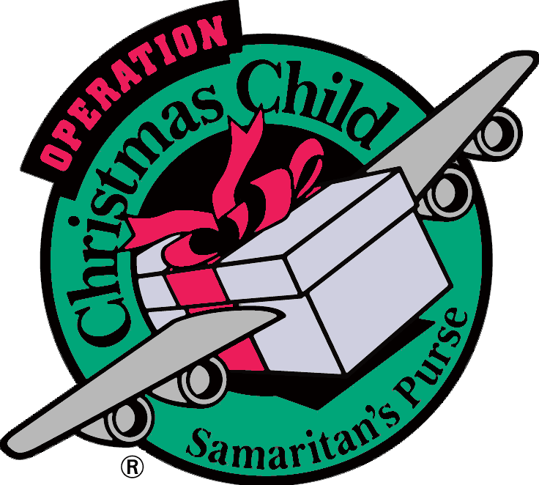 | SEC Service Day  Shopping for Operation Christmas Child | N2Y  Elective | Life Skills  Elective | Games  Art
17 | 18 | 19 | 20 | 21 | 22 | 23
 | Cooking  Elective  Optional Lunch Out  (Panda Express) | SEC Service Day  Delivering Boxes for Operation Christmas Child | N2Y  Elective | Life Skills  Elective | Field Trip:  Grand Premiere Lux  Frozen 2 ($20)
24 | 25 | 26 | 27 | 28 | 29 | 30
Ronald’s Birthday | Cooking  Elective | N2Y  Elective | SEC Family Thanksgiving Pot Luck Meal  12:00-2:00PM | CLOSED | CLOSED

