March 2020
Orange Team
Schedule
Sunday | Monday | Tuesday | Wednesday | Thursday | Friday | Saturday
1 | 2  Life skills  Elective | 3  N2Y  Elective | 4  Cooking  Elective | 5  Life Skills  Elective  Basketball Banquet  7-8:30PM | 6  Bingo  (The Villages of Dallas) | 7
8 | 9 | 10 | 11 | 12 | 13 | 14
Bowling at Red Bird Lanes in Duncanville  3-5pm  Morgan’s B-Day | Life skills  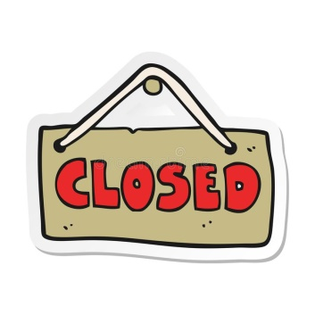  Elective | N2Y  Elective | Target Shopping  Elective | Life Skills  Elective | Art  Games
15 | 16 | 17 | 18 | 19 | 20 | 21
 | Frances’ B-Day | N2Y  Elective | Cooking  Elective | Orange Team Fun Day! | Art  Games
22 | 23 | 24 | 25 | 26 | 27 | 28
 | Life skills  Elective | N2Y  Elective | Cooking  Elective  Myrle’s B-Day | Life Skills  Elective  Order Lunch in  (Taco Bell) | Birthday Friday  ($4)
29 | 30 | 31
 | Life skills  Elective | N2Y  Elective |  |  | \

